**Revised Skypilot Selection Analyses**

Valerie Martin

9/20/2019

**Skypilot Selection Analyse with 75% Pollination Percentage and 2.5 Seed Maturity**

**Loading data and creating subsets…**

**Supplementation Experiment**

Niki: “Can’t use cumberland pass (no supplmement seeds were successfully collected…triple checking that). Marginal interaction effect: total seeds per plant increased with supplementation of skunky, but not sweet, flowers. Sweet has this weird relationship where sup seedset goes up with flower size. Jake swears size differences shouldn’t have influenced the effectiveness of the treatment.”

**Sweet morph only**

Niki: “no effect of habitat => remove no treatment effect, but Candi saw this in some years - might it relate to weaking selection?”

**qqnorm**(fruit.sw.np**$**Total.SeedsPerPlant)  
**qqline**(fruit.sw.np**$**Total.SeedsPerPlant)

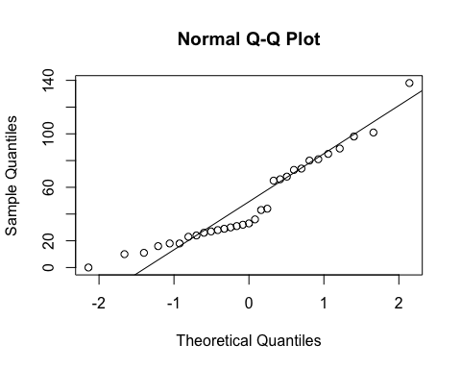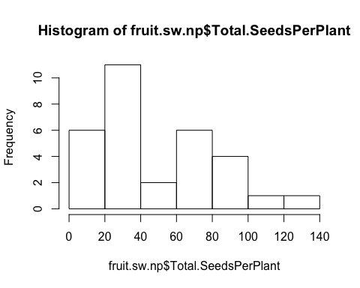

**hist**(fruit.sw.np**$**Total.SeedsPerPlant)

**qqnorm**(**sqrt**(fruit.sw.np**$**Total.SeedsPerPlant))  
**qqline**(**sqrt**(fruit.sw.np**$**Total.SeedsPerPlant))

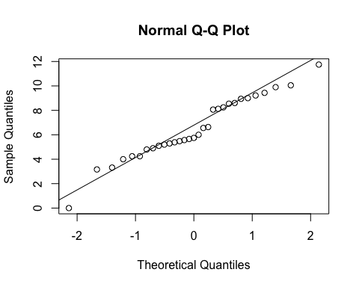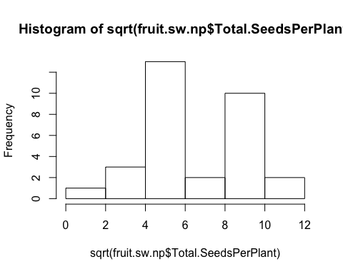

**hist**(**sqrt**(fruit.sw.np**$**Total.SeedsPerPlant))

basic.lm <- **lm**(**sqrt**(Total.SeedsPerPlant)**~**Treatment, data=fruit.sw.np)  
(prelim.plot <- **ggplot**(fruit.sw.np, **aes**(x=Treatment, y = Total.SeedsPerPlant))) **+**  
 **geom_point**()**+**  
 **geom_smooth**(method = "lm")

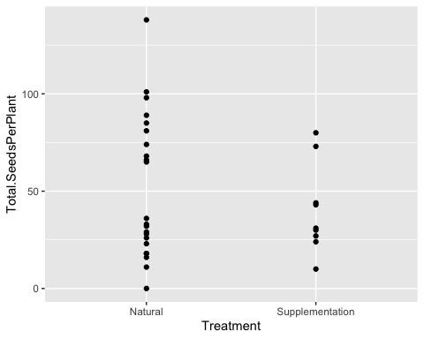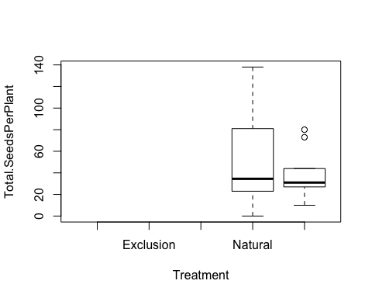

**boxplot**(Total.SeedsPerPlant **~** Treatment, data=fruit.sw.np)

**Selection - sweet flowers only**

*Would experience the strongest selection and sk flowers biased by habitat (almost exclusively in the krummholz).*

*Including Cumberland pass - replication is low but not biased.*

**Seeds per plant**

**Site**

**anova**(**lm**(**sqrt**(Total.SeedsPerPlant)**~**Site, data=fruit.sw.nat, na.action=na.omit))

## Analysis of Variance Table  
##   
## Response: sqrt(Total.SeedsPerPlant)  
##           Df  Sum Sq Mean Sq F value Pr(>F)  
## Site       2  36.933 18.4664  2.3277 0.1222  
## Residuals 21 166.601  7.9334

**TukeyHSD**(**aov**(**sqrt**(Total.SeedsPerPlant)**~**Site, data=fruit.sw.nat, na.action=na.omit))

##   Tukey multiple comparisons of means  
##     95% family-wise confidence level  
##   
## Fit: aov(formula = sqrt(Total.SeedsPerPlant) ~ Site, data = fruit.sw.nat, na.action = na.omit)  
##   
## $Site  
##                                    diff        lwr       upr     p adj  
## Niwot Ridge-Cumberland Pass   4.3977418 -1.5421295 10.337613 0.1732965  
## Penn Mountain-Cumberland Pass 4.5110782 -0.7961207  9.818277 0.1053194  
## Penn Mountain-Niwot Ridge     0.1133363 -3.4985153  3.725188 0.9965576

**ggplot**(fruit.sw.nat, **aes**(x=Site,y=Total.SeedsPerPlant)) **+**  
 **geom_boxplot**() **+**   
 **scale_y_sqrt**()**+**  
 **theme_bw**() **+**  
 **theme**(panel.grid.major = **element_blank**(), panel.grid.minor = **element_blank**(), text =**element_text**(size=20))

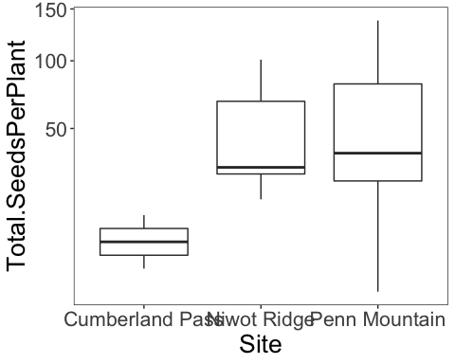

**Corolla Flare**

fit<-**lme**(**sqrt**(Total.SeedsPerPlant)**~**Avg.CorollaFlare, random=**~**1**|**Site, data=fruit.sw.nat, method="ML", na.action=na.omit)    
**anova.lme**(fit)

##                  numDF denDF   F-value p-value  
## (Intercept)          1    20 102.46415  <.0001  
## Avg.CorollaFlare     1    20   0.10458  0.7498

**ggplot**(fruit.sw.nat, **aes**(x=Avg.CorollaFlare,y=Total.SeedsPerPlant, color=Site)) **+**  
 **geom_point**(size=4) **+**   
 **scale_y_sqrt**()**+**  
 **ylab**("Seeds per plant") **+**  
 **xlab**("Corolla flare") **+**    
 **geom_hline**(yintercept=0) **+**  
 **theme_bw**() **+**  
 **theme**(panel.grid.major = **element_blank**(), panel.grid.minor = **element_blank**(), text =**element_text**(size=20), legend.position = "top")

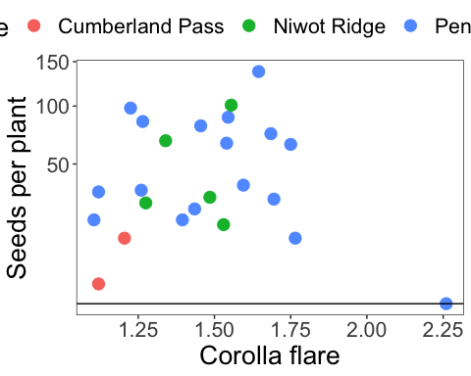

fit<-**lm**(**sqrt**(Total.SeedsPerPlant)**~**Avg.CorollaFlare**\***Site, data=fruit.sw.nat, na.action=na.omit)    
**Anova**(fit, type="III")

## Anova Table (Type III tests)  
##   
## Response: sqrt(Total.SeedsPerPlant)  
##                        Sum Sq Df F value Pr(>F)  
## (Intercept)             2.327  1  0.2808 0.6027  
## Avg.CorollaFlare        2.683  1  0.3237 0.5764  
## Site                    6.942  2  0.4187 0.6641  
## Avg.CorollaFlare:Site   5.680  2  0.3426 0.7144  
## Residuals             149.200 18

**Tube Length**

fit<-**lme**(**sqrt**(Total.SeedsPerPlant)**~**Avg.TubeL, random=**~**1**|**Site, data=fruit.sw.nat, method="ML", na.action=na.omit)    
**anova.lme**(fit)

##             numDF denDF   F-value p-value  
## (Intercept)     1    20 104.29029  <.0001  
## Avg.TubeL       1    20   0.49853  0.4883

**ggplot**(fruit.sw.nat, **aes**(x=Avg.TubeL,y=Total.SeedsPerPlant, color=Site)) **+**  
 **geom_point**(size=4) **+**   
 **scale_y_sqrt**()**+**  
 **ylab**("Seeds per plant") **+**  
 **xlab**("Tube length") **+**    
 **geom_hline**(yintercept=0) **+**  
 **theme_bw**() **+**  
 **theme**(panel.grid.major = **element_blank**(), panel.grid.minor = **element_blank**(), text =**element_text**(size=20), legend.position = "top")

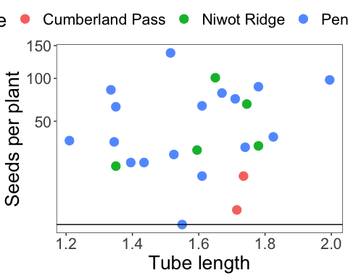

fit<-**lm**(**sqrt**(Total.SeedsPerPlant)**~**Avg.TubeL**\***Site, data=fruit.sw.nat, na.action=na.omit)    
**Anova**(fit, type="III")

## Anova Table (Type III tests)  
##   
## Response: sqrt(Total.SeedsPerPlant)  
##                 Sum Sq Df F value Pr(>F)  
## (Intercept)      2.626  1  0.3156 0.5812  
## Avg.TubeL        2.683  1  0.3225 0.5771  
## Site             4.405  2  0.2647 0.7704  
## Avg.TubeL:Site   4.111  2  0.2471 0.7837  
## Residuals      149.764 18

**Flower measurements combined via PCA**

**Flower measurements combined via PCA - Tube Length**

**cor**(fruit.sw.nat**$**Avg.CorollaFlare,fruit.sw.nat**$**Avg.TubeL)

## [1] 0.07765206

**cor.test**(fruit.sw.nat**$**Avg.CorollaFlare,fruit.sw.nat**$**Avg.TubeL)

##   
##  Pearson's product-moment correlation  
##   
## data:  fruit.sw.nat$Avg.CorollaFlare and fruit.sw.nat$Avg.TubeL  
## t = 0.36532, df = 22, p-value = 0.7184  
## alternative hypothesis: true correlation is not equal to 0  
## 95 percent confidence interval:  
##  -0.3362784  0.4664378  
## sample estimates:  
##        cor   
## 0.07765206

**plot**(fruit.sw.nat**$**Avg.CorollaFlare,fruit.sw.nat**$**Avg.TubeL)

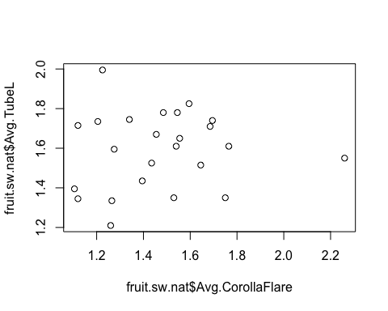

measures <- **c**("Avg.CorollaFlare", "Avg.TubeL")  
flwr.size<-**as.matrix**(**subset**(fruit.sw.nat, select=measures))  
pc<-**princomp**(flwr.size)  
pc<-**prcomp**(flwr.size,center=TRUE)  
**print**(pc)

## Standard deviations (1, .., p=2):  
## [1] 0.2655327 0.1919107  
##   
## Rotation (n x k) = (2 x 2):  
##                         PC1        PC2  
## Avg.CorollaFlare -0.9929312  0.1186915  
## Avg.TubeL        -0.1186915 -0.9929312

**plot**(pc, type="l")

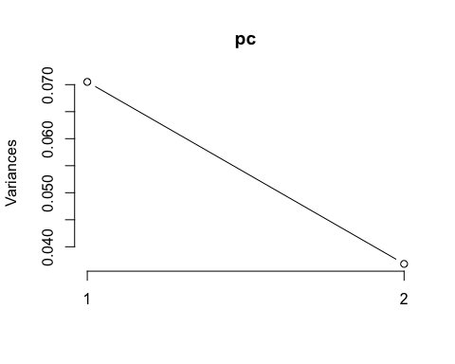

**summary**(pc)

## Importance of components:  
##                           PC1    PC2  
## Standard deviation     0.2655 0.1919  
## Proportion of Variance 0.6569 0.3431  
## Cumulative Proportion  0.6569 1.0000

pc.extracted <- **as.data.frame**(**predict**(pc, newdata=fruit.sw.nat))  
fruit.sw.nat**$**PC1 <- pc.extracted**$**PC1

**Flower measurement combined via PCA - Corolla Length**

fruit.sw.nat**$**CorollaL <- fruit.sw.nat**$**Avg.TubeL **+** fruit.sw.nat**$**Avg.LobeL  
**cor**(fruit.sw.nat**$**Avg.CorollaFlare,fruit.sw.nat**$**CorollaL)

## [1] 0.4511303

**cor.test**(fruit.sw.nat**$**Avg.CorollaFlare,fruit.sw.nat**$**CorollaL)

##   
##  Pearson's product-moment correlation  
##   
## data:  fruit.sw.nat$Avg.CorollaFlare and fruit.sw.nat$CorollaL  
## t = 2.371, df = 22, p-value = 0.02692  
## alternative hypothesis: true correlation is not equal to 0  
## 95 percent confidence interval:  
##  0.05835285 0.72295956  
## sample estimates:  
##       cor   
## 0.4511303

**plot**(fruit.sw.nat**$**Avg.CorollaFlare,fruit.sw.nat**$**CorollaL)

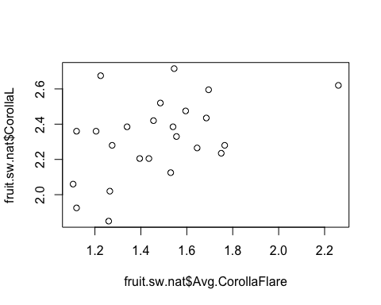

measures <- **c**("CorollaL", "Avg.CorollaFlare")  
flwr.size<-**as.matrix**(**subset**(fruit.sw.nat, select=measures))  
pc<-**prcomp**(flwr.size,center=TRUE)  
**print**(pc)

## Standard deviations (1, .., p=2):  
## [1] 0.2979192 0.1779617  
##   
## Rotation (n x k) = (2 x 2):  
##                        PC1        PC2  
## CorollaL         0.5726924  0.8197704  
## Avg.CorollaFlare 0.8197704 -0.5726924

**plot**(pc, type="l")

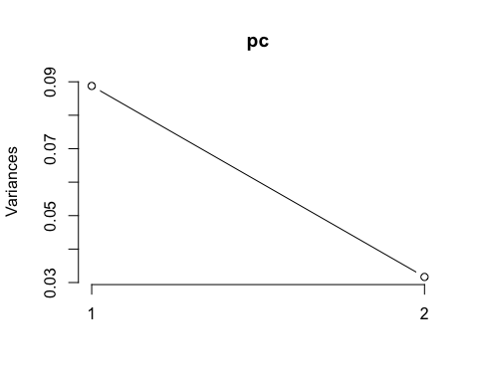

**summary**(pc)

## Importance of components:  
##                           PC1   PC2  
## Standard deviation     0.2979 0.178  
## Proportion of Variance 0.7370 0.263  
## Cumulative Proportion  0.7370 1.000

pc.extracted <- **as.data.frame**(**predict**(pc, newdata=fruit.sw.nat))  
fruit.sw.nat**$**PC1.cl <- pc.extracted**$**PC1

**Flower measurements combined via pca (all 4 traits - same as pressed)**

measures <- **c**("Avg.CorollaFlare", "Avg.TubeL", "Avg.LobeL", "Avg.LobW")  
flwr.size<-**as.matrix**(**subset**(fruit.sw.nat, select=measures))  
pc<-**prcomp**(flwr.size,center=TRUE)  
**print**(pc)

## Standard deviations (1, .., p=4):  
## [1] 0.29408912 0.19231785 0.06706734 0.05112285  
##   
## Rotation (n x k) = (4 x 4):  
##                          PC1         PC2         PC3         PC4  
## Avg.CorollaFlare -0.89383142  0.06820674 -0.36362083 -0.25336361  
## Avg.TubeL        -0.08435587 -0.99591155  0.02959356 -0.01298049  
## Avg.LobeL        -0.31121682  0.05660896  0.92433476 -0.21341219  
## Avg.LobW         -0.31159840  0.01741986  0.11184526  0.94344773

**plot**(pc, type="l")

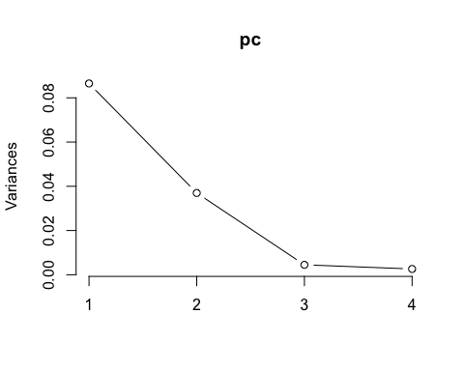

**summary**(pc)

## Importance of components:  
##                           PC1    PC2     PC3     PC4  
## Standard deviation     0.2941 0.1923 0.06707 0.05112  
## Proportion of Variance 0.6623 0.2832 0.03444 0.02001  
## Cumulative Proportion  0.6623 0.9455 0.97999 1.00000

pc.extracted <- **as.data.frame**(**predict**(pc, newdata=fruit.sw.nat))  
*##### Inverted PC1 when added to the df, because all loadings were negative.  This way, larger PC denotes a larger flower.*  
fruit.sw.nat**$**PC1.all <- **-**pc.extracted**$**PC1

**Total seedset per plant (annual fecundity)**

fit<-**lme**(**sqrt**(Total.SeedsPerPlant)**~**PC1.all, random=**~**1**|**Site, data=fruit.sw.nat, method="ML", na.action=na.omit)    
**anova.lme**(fit)

##             numDF denDF  F-value p-value  
## (Intercept)     1    20 102.3451  <.0001  
## PC1.all         1    20   0.0789  0.7817

**ggplot**(fruit.sw.nat, **aes**(x=PC1,y=Total.SeedsPerPlant, color=Site)) **+**  
 **geom_point**(size=4) **+**   
 **scale_y_sqrt**()**+**  
 **ylab**("Seeds per plant") **+**  
 **xlab**("PC1") **+**    
 **geom_hline**(yintercept=0) **+**  
 **theme_bw**() **+**  
 **theme**(panel.grid.major = **element_blank**(), panel.grid.minor = **element_blank**(), text =**element_text**(size=20), legend.position = "top")

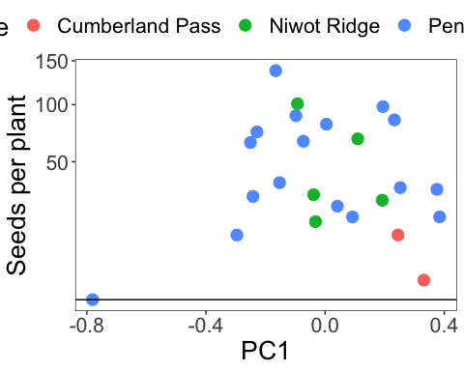

fit<-**lme**(**sqrt**(Total.SeedsPerPlant)**~**PC1.cl, random=**~**1**|**Site, data=fruit.sw.nat, method="ML", na.action=na.omit)    
**anova.lme**(fit)

##             numDF denDF   F-value p-value  
## (Intercept)     1    20 101.99401  <.0001  
## PC1.cl          1    20   0.00316  0.9558

**Relative fecundity (standardized by max annual fecundity)**

**max**(fruit.sw.nat**$**Total.SeedsPerPlant)

## [1] 138

fruit.sw.nat**$**RelativeFitness <- fruit.sw.nat**$**Total.SeedsPerPlant**/**138  
  
**qqnorm**(fruit.sw.nat**$**RelativeFitness)  
**qqline**(fruit.sw.nat**$**RelativeFitness)

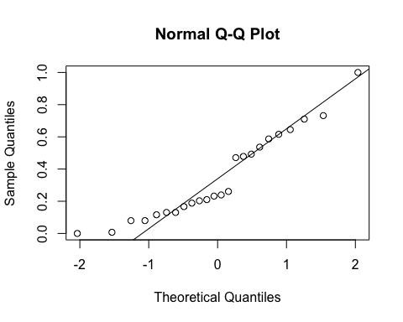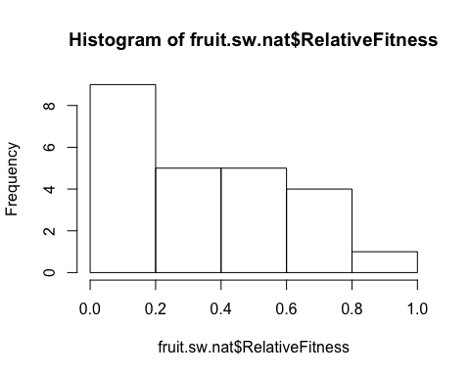

**hist**(fruit.sw.nat**$**RelativeFitness)

**qqnorm**(**sqrt**(fruit.sw.nat**$**RelativeFitness))  
**qqline**(**sqrt**(fruit.sw.nat**$**RelativeFitness))

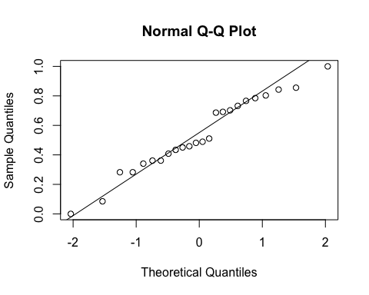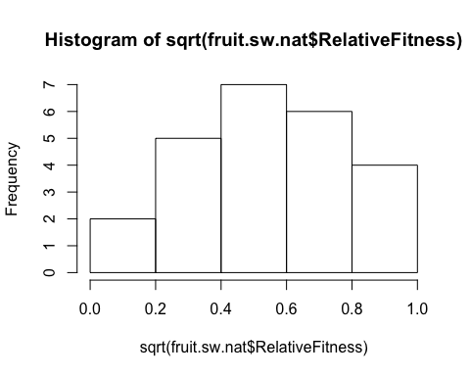

**hist**(**sqrt**(fruit.sw.nat**$**RelativeFitness))

fit<-**lme**(**sqrt**(RelativeFitness)**~**PC1, random=**~**1**|**Site, data=fruit.sw.nat, method="ML", na.action=na.omit)    
**anova.lme**(fit)

##             numDF denDF   F-value p-value  
## (Intercept)     1    20 102.29124  <.0001  
## PC1             1    20   0.06728   0.798

**ggplot**(fruit.sw.nat, **aes**(x=PC1,y=RelativeFitness)) **+**  
 **geom_point**(size=2) **+**   
 **scale_y_sqrt**()**+**  
 **scale_colour_manual**(values=**c**("black")) **+**  
 **ylab**("Relative fitness") **+**  
 **xlab**("PC1") **+**    
 **geom_hline**(yintercept=0) **+**  
 **theme_bw**() **+**  
 **theme**(panel.grid.major = **element_blank**(), panel.grid.minor = **element_blank**(), text =**element_text**(size=20))

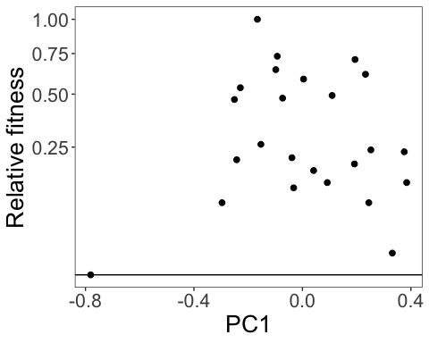

fit<-**lme**(**sqrt**(RelativeFitness)**~**PC1.cl, random=**~**1**|**Site, data=fruit.sw.nat, method="ML", na.action=na.omit)    
**anova.lme**(fit)

##             numDF denDF   F-value p-value  
## (Intercept)     1    20 101.99401  <.0001  
## PC1.cl          1    20   0.00316  0.9558

**ggplot**(fruit.sw.nat, **aes**(x=PC1.cl,y=RelativeFitness)) **+**  
 **geom_point**(size=2) **+**   
 **scale_y_sqrt**()**+**  
 **scale_colour_manual**(values=**c**("black")) **+**  
 **xlim**(**-**1,1) **+**  
 **ylab**("Relative fitness") **+**  
 **xlab**("PC1") **+**    
 **geom_hline**(yintercept=0) **+**  
 **theme_bw**() **+**  
 **theme**(panel.grid.major = **element_blank**(), panel.grid.minor = **element_blank**(), text =**element_text**(size=20))

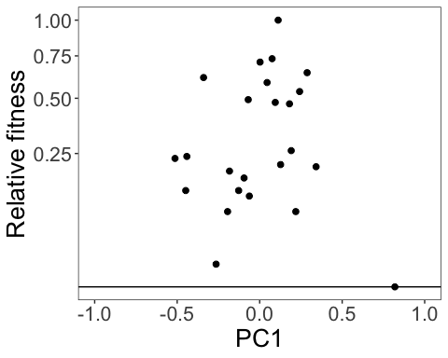

fit<-**lme**(**sqrt**(RelativeFitness)**~**Avg.CorollaFlare, random=**~**1**|**Site, data=fruit.sw.nat, method="ML", na.action=na.omit)    
**anova.lme**(fit)

##                  numDF denDF   F-value p-value  
## (Intercept)          1    20 102.46415  <.0001  
## Avg.CorollaFlare     1    20   0.10458  0.7498

**ggplot**(fruit.sw.nat, **aes**(x=CorollaL,y=RelativeFitness)) **+**  
 **geom_point**(size=2) **+**   
 **scale_y_sqrt**()**+**  
 **ylab**("Relative fitness") **+**  
 **xlab**("Corolla flare (cm)") **+**    
 **geom_hline**(yintercept=0) **+**  
 **theme_bw**() **+**  
 **theme**(panel.grid.major = **element_blank**(), panel.grid.minor = **element_blank**(), text =**element_text**(size=20))

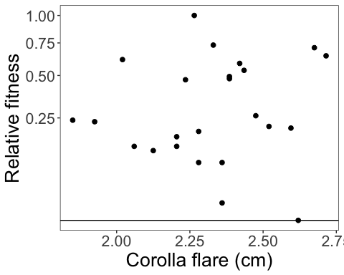

fit<-**lme**(**sqrt**(RelativeFitness)**~**CorollaL, random=**~**1**|**Site, data=fruit.sw.nat, method="ML", na.action=na.omit)    
**anova.lme**(fit)

##             numDF denDF   F-value p-value  
## (Intercept)     1    20 102.78108  <.0001  
## CorollaL        1    20   0.17295  0.6819

**ggplot**(fruit.sw.nat, **aes**(x=CorollaL,y=RelativeFitness)) **+**  
 **geom_point**(size=2) **+**   
 **scale_y_sqrt**()**+**  
 **ylab**("Relative fitness") **+**  
 **xlab**("Corolla length (cm)") **+**    
 **geom_hline**(yintercept=0) **+**  
 **theme_bw**() **+**  
 **theme**(panel.grid.major = **element_blank**(), panel.grid.minor = **element_blank**(), text =**element_text**(size=20))

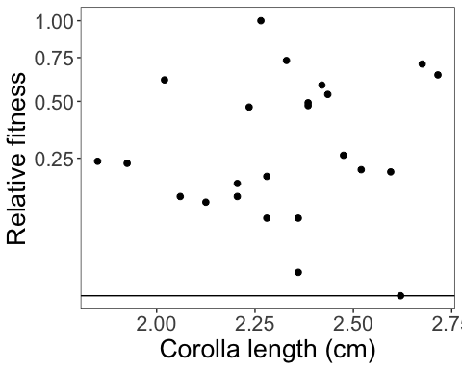

fit<-**lme**(**sqrt**(RelativeFitness)**~**Avg.TubeL, random=**~**1**|**Site, data=fruit.sw.nat, method="ML", na.action=na.omit)    
**anova.lme**(fit)

##             numDF denDF   F-value p-value  
## (Intercept)     1    20 104.29029  <.0001  
## Avg.TubeL       1    20   0.49853  0.4883

**ggplot**(fruit.sw.nat, **aes**(x=Avg.TubeL,y=RelativeFitness)) **+**  
 **geom_point**(size=2) **+**   
 **scale_y_sqrt**()**+**  
 **ylab**("Relative fitness") **+**  
 **xlab**("Flower tube length (cm)") **+**    
 **geom_hline**(yintercept=0) **+**  
 **theme_bw**() **+**  
 **theme**(panel.grid.major = **element_blank**(), panel.grid.minor = **element_blank**(), text =**element_text**(size=20))

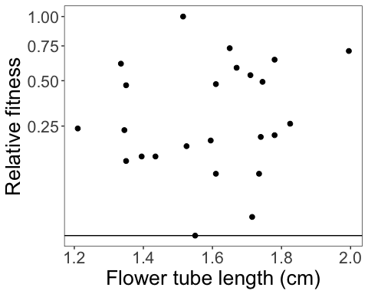

**With supplementation treatment**

*(treatment was more effective for larger flowers…Jake swears flwr size didn’t affect the trmt)*

**Total seedset per plant**

**qqnorm**(fruit.sw**$**Total.SeedsPerPlant)  
**qqline**(fruit.sw**$**Total.SeedsPerPlant)

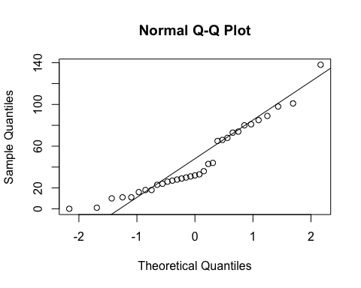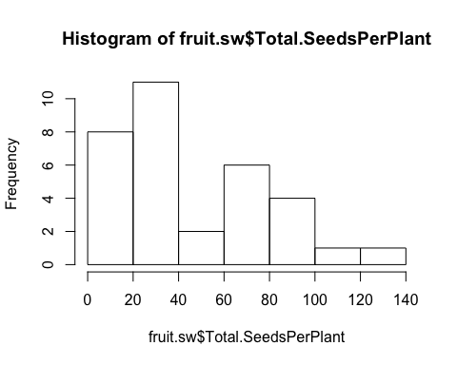

**hist**(fruit.sw**$**Total.SeedsPerPlant)

**qqnorm**(**sqrt**(fruit.sw**$**Total.SeedsPerPlant))  
**qqline**(**sqrt**(fruit.sw**$**Total.SeedsPerPlant))

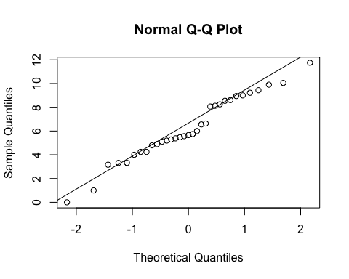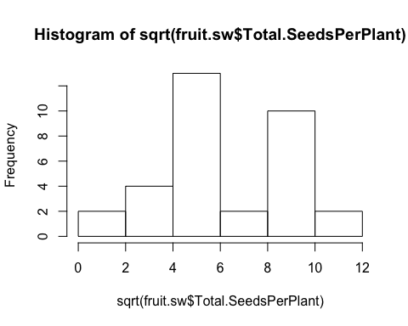

**hist**(**sqrt**(fruit.sw**$**Total.SeedsPerPlant))

fit<-**lme**(**sqrt**(Total.SeedsPerPlant)**~**Treatment**\***Avg.CorollaFlare, random=**~**1**|**Site**/**Habitat, data=fruit.sw, method="ML", na.action=na.omit)    
**anova.lme**(fit)

##                            numDF denDF   F-value p-value  
## (Intercept)                    1    24 21.356462  0.0001  
## Treatment                      1    24  0.275783  0.6043  
## Avg.CorollaFlare               1    24  0.737663  0.3989  
## Treatment:Avg.CorollaFlare     1    24  0.428068  0.5192

**summary**(fit)

## Linear mixed-effects model fit by maximum likelihood  
##  Data: fruit.sw   
##        AIC      BIC    logLik  
##   171.1115 181.5871 -78.55577  
##   
## Random effects:  
##  Formula: ~1 | Site  
##         (Intercept)  
## StdDev:    1.489304  
##   
##  Formula: ~1 | Habitat %in% Site  
##         (Intercept) Residual  
## StdDev:   0.9348935 2.386104  
##   
## Fixed effects: sqrt(Total.SeedsPerPlant) ~ Treatment * Avg.CorollaFlare   
##                                               Value Std.Error DF  
## (Intercept)                                8.821850  3.206563 24  
## TreatmentSupplementation                  -4.255062  5.850874 24  
## Avg.CorollaFlare                          -2.280919  2.113164 24  
## TreatmentSupplementation:Avg.CorollaFlare  2.489709  3.805328 24  
##                                              t-value p-value  
## (Intercept)                                2.7511857  0.0111  
## TreatmentSupplementation                  -0.7272524  0.4741  
## Avg.CorollaFlare                          -1.0793858  0.2911  
## TreatmentSupplementation:Avg.CorollaFlare  0.6542693  0.5192  
##  Correlation:   
##                                           (Intr) TrtmnS Avg.CF  
## TreatmentSupplementation                  -0.524                
## Avg.CorollaFlare                          -0.926  0.571         
## TreatmentSupplementation:Avg.CorollaFlare  0.528 -0.985 -0.587  
##   
## Standardized Within-Group Residuals:  
##        Min         Q1        Med         Q3        Max   
## -1.7222221 -0.7196726 -0.3798795  0.7869317  2.0765876   
##   
## Number of Observations: 33  
## Number of Groups:   
##              Site Habitat %in% Site   
##                 3                 6

**ggplot**(fruit.sw, **aes**(x=Avg.CorollaFlare,y=Total.SeedsPerPlant, color=Treatment, shape=Treatment)) **+**  
 **scale_shape_manual**(values=**c**(16,17)) **+**  
 **geom_point**(size=4) **+**   
 **scale_y_sqrt**()**+**  
 **scale_colour_manual**(values=**c**("blue", "red")) **+**  
 **geom_smooth**(method='lm', fill=NA) **+**  
 **theme_bw**() **+**  
 **theme**(panel.grid.major = **element_blank**(), panel.grid.minor = **element_blank**(), text =**element_text**(size=20))

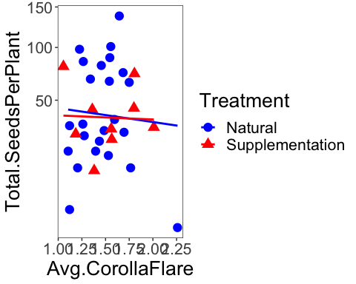

fit<-**lme**(**sqrt**(Total.SeedsPerPlant)**~**Avg.CorollaFlare, random=**~**1**|**Site**/**Habitat, data=fruit.sw.nat, method="ML", na.action=na.omit)    
**anova.lme**(fit)

##                  numDF denDF  F-value p-value  
## (Intercept)          1    17 89.26396  <.0001  
## Avg.CorollaFlare     1    17  0.15478  0.6989

fit<-**lme**(**sqrt**(Total.SeedsPerPlant)**~**Avg.CorollaFlare, random=**~**1**|**Site**/**Habitat, data=fruit.sw.sup, method="ML", na.action=na.omit)    
**anova.lme**(fit)

##                  numDF denDF  F-value p-value  
## (Intercept)          1     5 90.16391  0.0002  
## Avg.CorollaFlare     1     5  0.01070  0.9216

fit<-**lme**(**sqrt**(Total.SeedsPerPlant)**~**Treatment**\***Avg.TubeL, random=**~**1**|**Site**/**Habitat, data=fruit.sw, method="ML", na.action=na.omit)    
**anova.lme**(fit)

##                     numDF denDF  F-value p-value  
## (Intercept)             1    24 37.11706  <.0001  
## Treatment               1    24  0.17806  0.6768  
## Avg.TubeL               1    24  0.21963  0.6435  
## Treatment:Avg.TubeL     1    24  1.43656  0.2424

fit<-**lme**(**sqrt**(Total.SeedsPerPlant)**~**Treatment**\***CorollaL, random=**~**1**|**Site**/**Habitat, data=fruit.sw, method="ML", na.action=na.omit)    
**anova.lme**(fit)

##                    numDF denDF   F-value p-value  
## (Intercept)            1    24 149.86967  <.0001  
## Treatment              1    24   0.03528  0.8526  
## CorollaL               1    24   0.01927  0.8908  
## Treatment:CorollaL     1    24   1.21095  0.2821

**Relative fitness**

fit<-**lme**(**sqrt**(RelativeFitness)**~**Treatment**\***Avg.CorollaFlare, random=**~**1**|**Site, data=fruit.sw, method="ML", na.action=na.omit)    
**anova.lme**(fit)

##                            numDF denDF   F-value p-value  
## (Intercept)                    1    27 162.24188  <.0001  
## Treatment                      1    27   0.02147  0.8846  
## Avg.CorollaFlare               1    27   0.10733  0.7457  
## Treatment:Avg.CorollaFlare     1    27   0.01986  0.8890

fit<-**lme**(**sqrt**(RelativeFitness)**~**Treatment**\***Avg.CorollaFlare, random=**~**1**|**Site, data=fruit.sw, method="ML", na.action=na.omit)    
**anova.lme**(fit)

##                            numDF denDF   F-value p-value  
## (Intercept)                    1    27 162.24188  <.0001  
## Treatment                      1    27   0.02147  0.8846  
## Avg.CorollaFlare               1    27   0.10733  0.7457  
## Treatment:Avg.CorollaFlare     1    27   0.01986  0.8890

fit<-**lme**(**sqrt**(RelativeFitness)**~**Treatment**\***Avg.CorollaFlare, random=**~**1**|**Site, data=fruit.sw, method="ML", na.action=na.omit)    
**anova.lme**(fit)

##                            numDF denDF   F-value p-value  
## (Intercept)                    1    27 162.24188  <.0001  
## Treatment                      1    27   0.02147  0.8846  
## Avg.CorollaFlare               1    27   0.10733  0.7457  
## Treatment:Avg.CorollaFlare     1    27   0.01986  0.8890

**Seeds per fruit**

**qqnorm**(fruit.sw**$**No.SeedsPerFruit)  
**qqline**(fruit.sw**$**No.SeedsPerFruit)

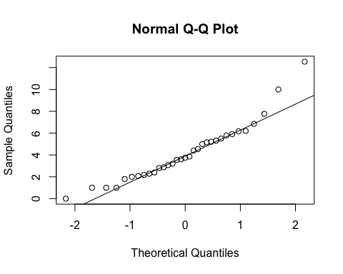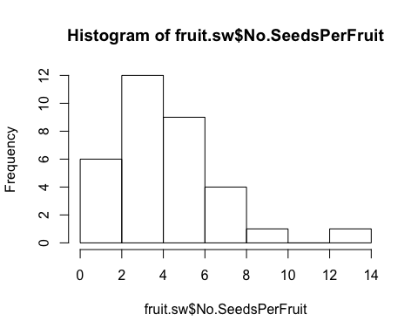

**hist**(fruit.sw**$**No.SeedsPerFruit)

**qqnorm**(**sqrt**(fruit.sw**$**No.SeedsPerFruit))  
**qqline**(**sqrt**(fruit.sw**$**No.SeedsPerFruit))

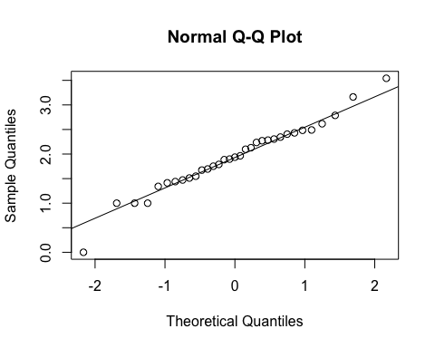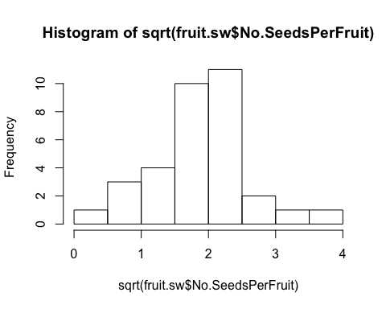

**hist**(**sqrt**(fruit.sw**$**No.SeedsPerFruit))

fit<-**lme**(**sqrt**(No.SeedsPerFruit)**~**Treatment**\***Avg.CorollaFlare, random=**~**1**|**Site**/**Habitat, data=fruit.sw, method="ML", na.action=na.omit)    
**anova.lme**(fit)

##                            numDF denDF   F-value p-value  
## (Intercept)                    1    24 192.18865  <.0001  
## Treatment                      1    24   0.81257  0.3763  
## Avg.CorollaFlare               1    24   0.34061  0.5649  
## Treatment:Avg.CorollaFlare     1    24   0.23904  0.6293

**summary**(fit)

## Linear mixed-effects model fit by maximum likelihood  
##  Data: fruit.sw   
##        AIC      BIC    logLik  
##   80.06388 90.53943 -33.03194  
##   
## Random effects:  
##  Formula: ~1 | Site  
##          (Intercept)  
## StdDev: 2.041652e-05  
##   
##  Formula: ~1 | Habitat %in% Site  
##         (Intercept) Residual  
## StdDev:   0.1159267 0.649319  
##   
## Fixed effects: sqrt(No.SeedsPerFruit) ~ Treatment * Avg.CorollaFlare   
##                                                Value Std.Error DF  
## (Intercept)                                2.4569167 0.8182418 24  
## TreatmentSupplementation                  -0.4583646 1.4915181 24  
## Avg.CorollaFlare                          -0.4168601 0.5496686 24  
## TreatmentSupplementation:Avg.CorollaFlare  0.4754465 0.9724569 24  
##                                              t-value p-value  
## (Intercept)                                3.0026781  0.0062  
## TreatmentSupplementation                  -0.3073141  0.7613  
## Avg.CorollaFlare                          -0.7583844  0.4556  
## TreatmentSupplementation:Avg.CorollaFlare  0.4889126  0.6293  
##  Correlation:   
##                                           (Intr) TrtmnS Avg.CF  
## TreatmentSupplementation                  -0.553                
## Avg.CorollaFlare                          -0.982  0.550         
## TreatmentSupplementation:Avg.CorollaFlare  0.559 -0.983 -0.572  
##   
## Standardized Within-Group Residuals:  
##        Min         Q1        Med         Q3        Max   
## -2.2828362 -0.6088899 -0.1107179  0.5805145  2.5904688   
##   
## Number of Observations: 33  
## Number of Groups:   
##              Site Habitat %in% Site   
##                 3                 6

**ggplot**(fruit.sw, **aes**(x=Avg.CorollaFlare,y=No.SeedsPerFruit, color=Treatment, shape=Treatment)) **+**  
 **scale_shape_manual**(values=**c**(16,17)) **+**  
 **geom_point**(size=4) **+**   
 **scale_y_sqrt**()**+**  
 **scale_colour_manual**(values=**c**("blue", "red")) **+**  
 **geom_smooth**(method='lm', fill=NA) **+**  
 **theme_bw**() **+**  
 **theme**(panel.grid.major = **element_blank**(), panel.grid.minor = **element_blank**(), text =**element_text**(size=20))

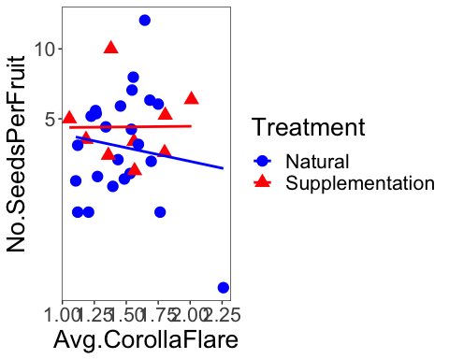

fit<-**lme**(**sqrt**(No.SeedsPerFruit)**~**Treatment**\***Avg.TubeL, random=**~**1**|**Site**/**Habitat, data=fruit.sw, method="ML", na.action=na.omit)    
**anova.lme**(fit)

##                     numDF denDF   F-value p-value  
## (Intercept)             1    24 246.74218  <.0001  
## Treatment               1    24   0.91555  0.3482  
## Avg.TubeL               1    24   0.01476  0.9043  
## Treatment:Avg.TubeL     1    24   0.00327  0.9549

**summary**(fit)

## Linear mixed-effects model fit by maximum likelihood  
##  Data: fruit.sw   
##        AIC      BIC    logLik  
##   80.61328 91.08883 -33.30664  
##   
## Random effects:  
##  Formula: ~1 | Site  
##          (Intercept)  
## StdDev: 0.0001180302  
##   
##  Formula: ~1 | Habitat %in% Site  
##         (Intercept)  Residual  
## StdDev: 0.001923969 0.6638821  
##   
## Fixed effects: sqrt(No.SeedsPerFruit) ~ Treatment * Avg.TubeL   
##                                         Value Std.Error DF    t-value  
## (Intercept)                         1.9590919 1.2245196 24  1.5998861  
## TreatmentSupplementation            0.4183611 2.5897643 24  0.1615441  
## Avg.TubeL                          -0.0595821 0.7645515 24 -0.0779307  
## TreatmentSupplementation:Avg.TubeL -0.0893234 1.5613832 24 -0.0572079  
##                                    p-value  
## (Intercept)                         0.1227  
## TreatmentSupplementation            0.8730  
## Avg.TubeL                           0.9385  
## TreatmentSupplementation:Avg.TubeL  0.9549  
##  Correlation:   
##                                    (Intr) TrtmnS Avg.TL  
## TreatmentSupplementation           -0.473                
## Avg.TubeL                          -0.993  0.470         
## TreatmentSupplementation:Avg.TubeL  0.486 -0.994 -0.490  
##   
## Standardized Within-Group Residuals:  
##         Min          Q1         Med          Q3         Max   
## -2.81183381 -0.60145996  0.01005842  0.64904257  2.52018254   
##   
## Number of Observations: 33  
## Number of Groups:   
##              Site Habitat %in% Site   
##                 3                 6

fit<-**lme**(**sqrt**(No.SeedsPerFruit)**~**Treatment**\***Avg.LobW, random=**~**1**|**Site**/**Habitat, data=fruit.sw, method="ML")    
**anova.lme**(fit)

##                    numDF denDF   F-value p-value  
## (Intercept)            1    24 214.62277  <.0001  
## Treatment              1    24   0.86042  0.3629  
## Avg.LobW               1    24   0.01262  0.9115  
## Treatment:Avg.LobW     1    24   0.70956  0.4079

**summary**(fit)

## Linear mixed-effects model fit by maximum likelihood  
##  Data: fruit.sw   
##        AIC      BIC    logLik  
##   79.84857 90.32412 -32.92429  
##   
## Random effects:  
##  Formula: ~1 | Site  
##          (Intercept)  
## StdDev: 1.993909e-05  
##   
##  Formula: ~1 | Habitat %in% Site  
##         (Intercept)  Residual  
## StdDev:  0.08746979 0.6508099  
##   
## Fixed effects: sqrt(No.SeedsPerFruit) ~ Treatment * Avg.LobW   
##                                        Value Std.Error DF    t-value  
## (Intercept)                        2.4849741  1.049107 24  2.3686570  
## TreatmentSupplementation          -1.2256886  1.782355 24 -0.6876792  
## Avg.LobW                          -0.8500189  1.398207 24 -0.6079350  
## TreatmentSupplementation:Avg.LobW  1.9250836  2.285356 24  0.8423562  
##                                   p-value  
## (Intercept)                        0.0262  
## TreatmentSupplementation           0.4982  
## Avg.LobW                           0.5489  
## TreatmentSupplementation:Avg.LobW  0.4079  
##  Correlation:   
##                                   (Intr) TrtmnS Avg.LW  
## TreatmentSupplementation          -0.593                
## Avg.LobW                          -0.990  0.589         
## TreatmentSupplementation:Avg.LobW  0.610 -0.988 -0.617  
##   
## Standardized Within-Group Residuals:  
##         Min          Q1         Med          Q3         Max   
## -2.44530624 -0.61214422 -0.08262948  0.59374326  2.58556785   
##   
## Number of Observations: 33  
## Number of Groups:   
##              Site Habitat %in% Site   
##                 3                 6

fit<-**lme**(**sqrt**(No.SeedsPerFruit)**~**Treatment**\***Avg.LobeL, random=**~**1**|**Site**/**Habitat, data=fruit.sw, method="ML")    
**anova.lme**(fit)

##                     numDF denDF   F-value p-value  
## (Intercept)             1    24 163.40714  <.0001  
## Treatment               1    24   0.76287  0.3911  
## Avg.LobeL               1    24   0.55117  0.4650  
## Treatment:Avg.LobeL     1    24   0.73422  0.4000

**summary**(fit)

## Linear mixed-effects model fit by maximum likelihood  
##  Data: fruit.sw   
##        AIC     BIC    logLik  
##   79.45355 89.9291 -32.72677  
##   
## Random effects:  
##  Formula: ~1 | Site  
##          (Intercept)  
## StdDev: 2.686009e-05  
##   
##  Formula: ~1 | Habitat %in% Site  
##         (Intercept)  Residual  
## StdDev:   0.1573564 0.6368502  
##   
## Fixed effects: sqrt(No.SeedsPerFruit) ~ Treatment * Avg.LobeL   
##                                        Value Std.Error DF    t-value  
## (Intercept)                         2.753479  0.947910 24  2.9047905  
## TreatmentSupplementation           -2.297002  2.954336 24 -0.7775019  
## Avg.LobeL                          -1.265399  1.285691 24 -0.9842173  
## TreatmentSupplementation:Avg.LobeL  3.475440  4.055982 24  0.8568676  
##                                    p-value  
## (Intercept)                         0.0078  
## TreatmentSupplementation            0.4445  
## Avg.LobeL                           0.3348  
## TreatmentSupplementation:Avg.LobeL  0.4000  
##  Correlation:   
##                                    (Intr) TrtmnS Avg.LL  
## TreatmentSupplementation           -0.333                
## Avg.LobeL                          -0.985  0.334         
## TreatmentSupplementation:Avg.LobeL  0.324 -0.996 -0.331  
##   
## Standardized Within-Group Residuals:  
##        Min         Q1        Med         Q3        Max   
## -2.1245064 -0.6389516 -0.2328628  0.6667217  2.4881385   
##   
## Number of Observations: 33  
## Number of Groups:   
##              Site Habitat %in% Site   
##                 3                 6

**Both morphs: natural treatment only**

**Seeds per plant**

*Without supplementation treatment*

**qqnorm**(fruit.nat**$**Total.SeedsPerPlant)  
**qqline**(fruit.nat**$**Total.SeedsPerPlant)

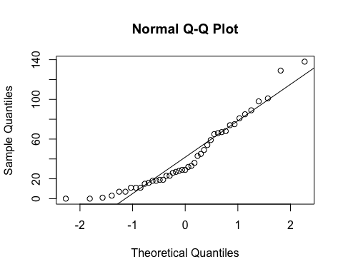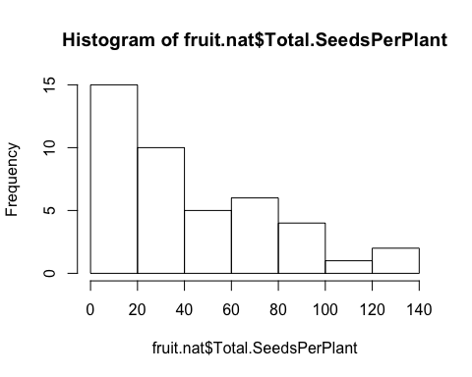

**hist**(fruit.nat**$**Total.SeedsPerPlant)

**qqnorm**(**sqrt**(fruit.nat**$**Total.SeedsPerPlant))  
**qqline**(**sqrt**(fruit.nat**$**Total.SeedsPerPlant))

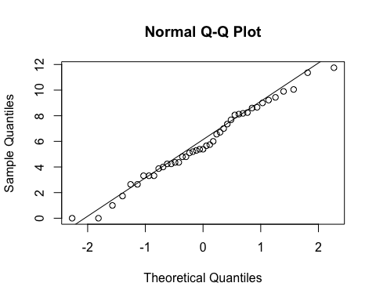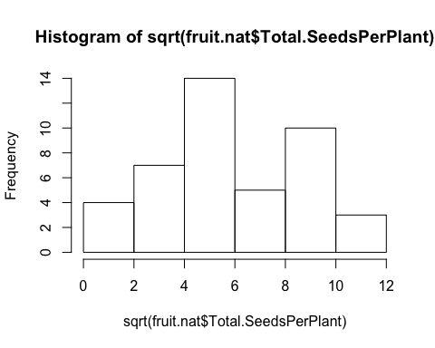

**hist**(**sqrt**(fruit.nat**$**Total.SeedsPerPlant))

*####Site*  
**anova**(**lm**(**sqrt**(Total.SeedsPerPlant)**~**Morph, data=fruit.nat, na.action=na.omit))

## Analysis of Variance Table  
##   
## Response: sqrt(Total.SeedsPerPlant)  
##           Df Sum Sq Mean Sq F value Pr(>F)  
## Morph      1   8.81  8.8127  1.0658  0.308  
## Residuals 41 339.03  8.2690

**anova**(**lm**(**sqrt**(Total.SeedsPerPlant)**~**Site, data=fruit.nat, na.action=na.omit))

## Analysis of Variance Table  
##   
## Response: sqrt(Total.SeedsPerPlant)  
##           Df  Sum Sq Mean Sq F value  Pr(>F)    
## Site       2  68.371  34.185  4.8929 0.01256 *  
## Residuals 40 279.469   6.987                    
## ---  
## Signif. codes:  0 '***' 0.001 '**' 0.01 '*' 0.05 '.' 0.1 ' ' 1

**TukeyHSD**(**aov**(**sqrt**(Total.SeedsPerPlant)**~**Site, data=fruit.nat, na.action=na.omit))

##   Tukey multiple comparisons of means  
##     95% family-wise confidence level  
##   
## Fit: aov(formula = sqrt(Total.SeedsPerPlant) ~ Site, data = fruit.nat, na.action = na.omit)  
##   
## $Site  
##                                    diff        lwr      upr     p adj  
## Niwot Ridge-Cumberland Pass   2.7539325 -0.2354300 5.743295 0.0762717  
## Penn Mountain-Cumberland Pass 3.3649434  0.7385034 5.991383 0.0092318  
## Penn Mountain-Niwot Ridge     0.6110109 -1.7314652 2.953487 0.8018811

**ggplot**(fruit.nat, **aes**(x=Site,y=No.SeedsPerFruit)) **+**  
 **geom_boxplot**() **+**   
 **scale_y_sqrt**()**+**  
 **theme_bw**() **+**  
 **theme**(panel.grid.major = **element_blank**(), panel.grid.minor = **element_blank**(), text =**element_text**(size=20))

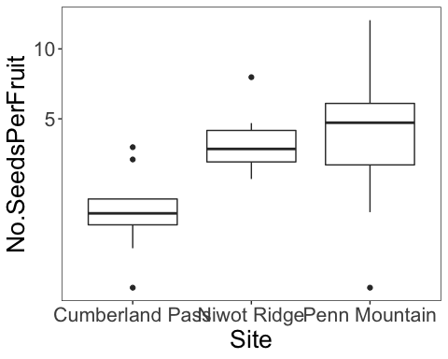

*#corolla flare*  
fit<-**lme**(**sqrt**(Total.SeedsPerPlant)**~**Avg.CorollaFlare**\***Morph, random=**~**1**|**Site, data=fruit.nat, method="ML", na.action=na.omit)    
**anova.lme**(fit)

##                        numDF denDF  F-value p-value  
## (Intercept)                1    37 32.17556  <.0001  
## Avg.CorollaFlare           1    37  1.08618  0.3041  
## Morph                      1    37  0.08497  0.7723  
## Avg.CorollaFlare:Morph     1    37  0.01911  0.8908

*#tube length*  
fit<-**lme**(**sqrt**(Total.SeedsPerPlant)**~**Avg.TubeL**\***Morph, random=**~**1**|**Site, data=fruit.nat, method="ML", na.action=na.omit)    
**anova.lme**(fit)

##                 numDF denDF  F-value p-value  
## (Intercept)         1    37 42.00901  <.0001  
## Avg.TubeL           1    37  0.06453  0.8009  
## Morph               1    37  0.24602  0.6228  
## Avg.TubeL:Morph     1    37  1.24365  0.2720

**Flower measurements combined via pca (all 4 traits - same as pressed)**

measures <- **c**("Avg.CorollaFlare", "Avg.TubeL", "Avg.LobeL", "Avg.LobW")  
flwr.size<-**as.matrix**(**subset**(fruit.nat, select=measures))  
pc<-**prcomp**(flwr.size,center=TRUE)  
**print**(pc)

## Standard deviations (1, .., p=4):  
## [1] 0.25076852 0.21385170 0.08529390 0.06907149  
##   
## Rotation (n x k) = (4 x 4):  
##                        PC1         PC2         PC3         PC4  
## Avg.CorollaFlare 0.8719149 -0.15491858  0.43200595  0.17069137  
## Avg.TubeL        0.1754685  0.98308948  0.01785694 -0.04926474  
## Avg.LobeL        0.3222640 -0.01996539 -0.83421169  0.44703259  
## Avg.LobW         0.3242239 -0.09558605 -0.34226136 -0.87669796

**plot**(pc, type="l")

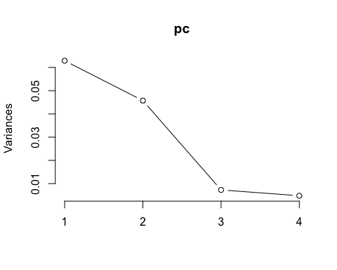

**summary**(pc)

## Importance of components:  
##                           PC1    PC2     PC3     PC4  
## Standard deviation     0.2508 0.2139 0.08529 0.06907  
## Proportion of Variance 0.5212 0.3790 0.06029 0.03954  
## Cumulative Proportion  0.5212 0.9002 0.96046 1.00000

pc.extracted <- **as.data.frame**(**predict**(pc, newdata=fruit.nat))  
fruit.nat**$**PC1.all <- pc.extracted**$**PC1   
*# annual fecundity*  
fit<-**lme**(**sqrt**(Total.SeedsPerPlant)**~**PC1.all**\***Morph, random=**~**1**|**Site, data=fruit.nat, method="ML", na.action=na.omit)    
**anova.lme**(fit)

##               numDF denDF   F-value p-value  
## (Intercept)       1    37 31.278519  <.0001  
## PC1.all           1    37  1.080836  0.3053  
## Morph             1    37  0.065479  0.7995  
## PC1.all:Morph     1    37  0.171193  0.6814

**ggplot**(fruit.nat, **aes**(x=Avg.CorollaFlare,y=No.SeedsPerFruit, color=Morph, shape=Treatment)) **+**  
 **scale_shape_manual**(values=**c**(16,17)) **+**  
 **geom_point**(size=4) **+**   
 **scale_y_sqrt**()**+**  
 **scale_colour_manual**(values=**c**("blue", "red")) **+**  
 **theme_bw**() **+**  
 **theme**(panel.grid.major = **element_blank**(), panel.grid.minor = **element_blank**(), text =**element_text**(size=20))

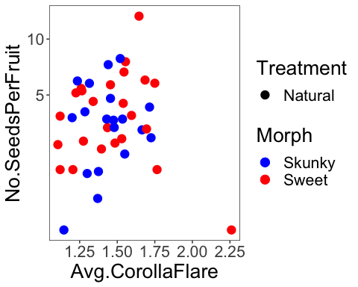

**All morphs: site, habitat and morph are random effects…**

**Seeds per fruit**

**qqnorm**(fruit.sm**$**No.SeedsPerFruit)  
**qqline**(fruit.sm**$**No.SeedsPerFruit)

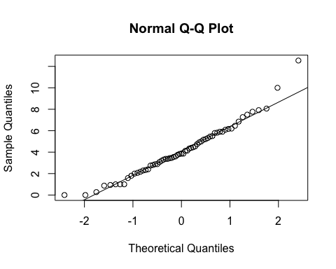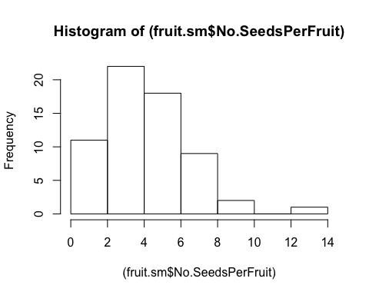

**hist**((fruit.sm**$**No.SeedsPerFruit))

**hist**(**sqrt**(fruit.sm**$**No.SeedsPerFruit))

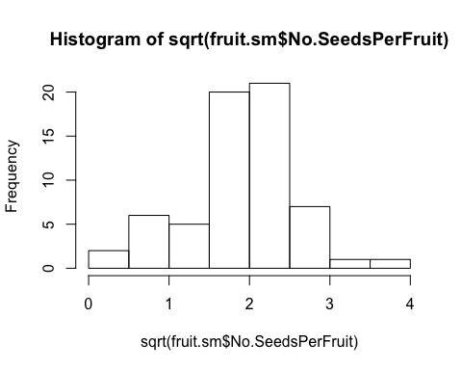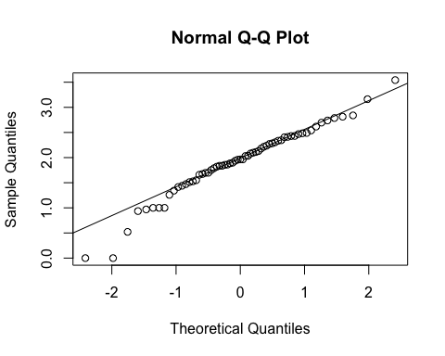

**qqnorm**(**sqrt**(fruit.sm**$**No.SeedsPerFruit))  
**qqline**(**sqrt**(fruit.sm**$**No.SeedsPerFruit))

fit<-**lme**(**sqrt**(No.SeedsPerFruit)**~**Treatment**\***Avg.CorollaFlare, random=**~**1**|**Site**/**Habitat**/**Morph, data=fruit.sm, method="ML", na.action=na.omit)    
**anova.lme**(fit)

##                            numDF denDF   F-value p-value  
## (Intercept)                    1    49 31.365406  <.0001  
## Treatment                      1    49  1.950010  0.1689  
## Avg.CorollaFlare               1    49  1.849166  0.1801  
## Treatment:Avg.CorollaFlare     1    49  1.218113  0.2751

**summary**(fit) *# sign. dif by treatment but difficult to interpret figures, if transformed looks like both go up with corolla flare and only intercept is different...*

## Linear mixed-effects model fit by maximum likelihood  
##  Data: fruit.sm   
##        AIC     BIC    logLik  
##   126.7399 143.885 -55.36994  
##   
## Random effects:  
##  Formula: ~1 | Site  
##         (Intercept)  
## StdDev:   0.4879243  
##   
##  Formula: ~1 | Habitat %in% Site  
##          (Intercept)  
## StdDev: 5.201003e-05  
##   
##  Formula: ~1 | Morph %in% Habitat %in% Site  
##         (Intercept)  Residual  
## StdDev:  0.08833186 0.5419991  
##   
## Fixed effects: sqrt(No.SeedsPerFruit) ~ Treatment * Avg.CorollaFlare   
##                                                Value Std.Error DF  
## (Intercept)                                2.6911644 0.6646253 49  
## TreatmentSupplementation                  -0.9247747 1.0417103 49  
## Avg.CorollaFlare                          -0.7276656 0.4155911 49  
## TreatmentSupplementation:Avg.CorollaFlare  0.7714139 0.6989460 49  
##                                             t-value p-value  
## (Intercept)                                4.049145  0.0002  
## TreatmentSupplementation                  -0.887746  0.3790  
## Avg.CorollaFlare                          -1.750917  0.0862  
## TreatmentSupplementation:Avg.CorollaFlare  1.103682  0.2751  
##  Correlation:   
##                                           (Intr) TrtmnS Avg.CF  
## TreatmentSupplementation                  -0.546                
## Avg.CorollaFlare                          -0.887  0.614         
## TreatmentSupplementation:Avg.CorollaFlare  0.536 -0.988 -0.612  
##   
## Standardized Within-Group Residuals:  
##        Min         Q1        Med         Q3        Max   
## -2.5352836 -0.5825062 -0.1368654  0.5371263  2.9844282   
##   
## Number of Observations: 63  
## Number of Groups:   
##                         Site            Habitat %in% Site   
##                            3                            6   
## Morph %in% Habitat %in% Site   
##                           11

fruit.nat <- **subset**(fruit.sm, Treatment**==**"Natural")  
fruit.sup <- **subset**(fruit.sm, Treatment**==**"Supplementation")  
  
fit<-**lme**(**sqrt**(No.SeedsPerFruit)**~**Avg.CorollaFlare, random=**~**1**|**Site**/**Habitat, data=fruit.nat, method="ML")  
**anova.lme**(fit)

##                  numDF denDF   F-value p-value  
## (Intercept)          1    36 29.048421  <.0001  
## Avg.CorollaFlare     1    36  2.966691  0.0936

fit<-**lme**(**sqrt**(No.SeedsPerFruit)**~**Avg.CorollaFlare, random=**~**1**|**Site**/**Habitat, data=fruit.sup, method="ML")  
**anova.lme**(fit)

##                  numDF denDF  F-value p-value  
## (Intercept)          1    15 595.6668  <.0001  
## Avg.CorollaFlare     1    15   0.0370  0.8501

fit<-**lme**(**sqrt**(No.SeedsPerFruit)**~**Treatment**\***Avg.TubeL, random=**~**1**|**Site**/**Habitat**/**Morph, data=fruit.sm, method="ML")    
**anova.lme**(fit)

##                     numDF denDF  F-value p-value  
## (Intercept)             1    49 45.45105  <.0001  
## Treatment               1    49  2.12481  0.1513  
## Avg.TubeL               1    49  0.01197  0.9133  
## Treatment:Avg.TubeL     1    49  0.06489  0.8000

**summary**(fit)

## Linear mixed-effects model fit by maximum likelihood  
##  Data: fruit.sm   
##        AIC     BIC    logLik  
##   129.5879 146.733 -56.79396  
##   
## Random effects:  
##  Formula: ~1 | Site  
##         (Intercept)  
## StdDev:   0.3994074  
##   
##  Formula: ~1 | Habitat %in% Site  
##          (Intercept)  
## StdDev: 3.413248e-05  
##   
##  Formula: ~1 | Morph %in% Habitat %in% Site  
##         (Intercept)  Residual  
## StdDev:  0.04586921 0.5635631  
##   
## Fixed effects: sqrt(No.SeedsPerFruit) ~ Treatment * Avg.TubeL   
##                                         Value Std.Error DF    t-value  
## (Intercept)                         1.8304037 0.7624397 49  2.4007193  
## TreatmentSupplementation           -0.0847926 1.2907410 49 -0.0656930  
## Avg.TubeL                          -0.0991629 0.4295068 49 -0.2308762  
## TreatmentSupplementation:Avg.TubeL  0.2003806 0.7866185 49  0.2547367  
##                                    p-value  
## (Intercept)                         0.0202  
## TreatmentSupplementation            0.9479  
## Avg.TubeL                           0.8184  
## TreatmentSupplementation:Avg.TubeL  0.8000  
##  Correlation:   
##                                    (Intr) TrtmnS Avg.TL  
## TreatmentSupplementation           -0.516                
## Avg.TubeL                          -0.941  0.546         
## TreatmentSupplementation:Avg.TubeL  0.510 -0.992 -0.547  
##   
## Standardized Within-Group Residuals:  
##        Min         Q1        Med         Q3        Max   
## -3.5040031 -0.5372276 -0.0903510  0.6228894  2.7256253   
##   
## Number of Observations: 63  
## Number of Groups:   
##                         Site            Habitat %in% Site   
##                            3                            6   
## Morph %in% Habitat %in% Site   
##                           11

fit<-**lme**(**sqrt**(No.SeedsPerFruit)**~**Avg.LobeL, random=**~**1**|**Site**/**Habitat**/**Morph, data=fruit.nat, method="ML")    
**anova.lme**(fit)

##             numDF denDF   F-value p-value  
## (Intercept)     1    32 28.727649  <.0001  
## Avg.LobeL       1    32  3.717195  0.0628

**summary**(fit)

## Linear mixed-effects model fit by maximum likelihood  
##  Data: fruit.nat   
##       AIC      BIC   logLik  
##   96.2176 106.7848 -42.1088  
##   
## Random effects:  
##  Formula: ~1 | Site  
##         (Intercept)  
## StdDev:    0.475752  
##   
##  Formula: ~1 | Habitat %in% Site  
##         (Intercept)  
## StdDev:   0.1139708  
##   
##  Formula: ~1 | Morph %in% Habitat %in% Site  
##         (Intercept)  Residual  
## StdDev:   0.2068192 0.5717994  
##   
## Fixed effects: sqrt(No.SeedsPerFruit) ~ Avg.LobeL   
##                 Value Std.Error DF   t-value p-value  
## (Intercept)  2.848245 0.6877889 32  4.141162  0.0002  
## Avg.LobeL   -1.696629 0.8799928 32 -1.928003  0.0628  
##  Correlation:   
##           (Intr)  
## Avg.LobeL -0.892  
##   
## Standardized Within-Group Residuals:  
##         Min          Q1         Med          Q3         Max   
## -2.06198107 -0.68738053 -0.04854231  0.74191035  2.37079837   
##   
## Number of Observations: 43  
## Number of Groups:   
##                         Site            Habitat %in% Site   
##                            3                            6   
## Morph %in% Habitat %in% Site   
##                           10

**ggplot**(fruit.sm, **aes**(x=Avg.CorollaFlare,y=No.SeedsPerFruit, color=Treatment, shape=Treatment)) **+**  
 **geom_point**(size=4) **+**   
 **scale_colour_manual**(values=**c**("blue", "red")) **+**  
 **xlim**(0.8,2.4) **+**  
 **ylim**(0,15) **+**  
 **geom_smooth**(method='lm', **aes**(linetype=Treatment), fill=NA) **+**  
 **ylab**("Number of seeds per fruit") **+**  
 **xlab**("Corolla Flare (cm)") **+**  
 **geom_hline**(yintercept=0, linetype="dashed") **+**  
 **theme_bw**() **+**  
 **theme**(panel.grid.major = **element_blank**(), panel.grid.minor = **element_blank**(), text =**element_text**(size=20))

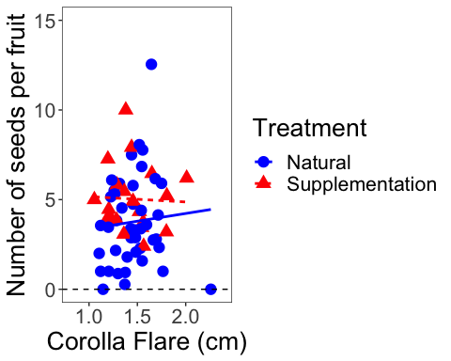

**ggplot**(fruit.sm, **aes**(x=Avg.CorollaFlare,y=No.SeedsPerFruit, color=Treatment, shape=Treatment)) **+**  
 **geom_point**(size=4) **+**   
 **scale_y_continuous**(limits=**c**(0,15), trans="sqrt") **+**  
 **xlim**(0.8,2.4) **+**  
 **scale_colour_manual**(values=**c**("blue", "red")) **+**  
 **geom_smooth**(method='lm', **aes**(linetype=Treatment), fill=NA) **+**  
 **ylab**("Number of seeds per fruit") **+**  
 **xlab**("Corolla Flare (cm)") **+**  
 **geom_hline**(yintercept=0, linetype="dashed") **+**  
 **theme_bw**() **+**  
 **theme**(panel.grid.major = **element_blank**(), panel.grid.minor = **element_blank**(), text =**element_text**(size=20))

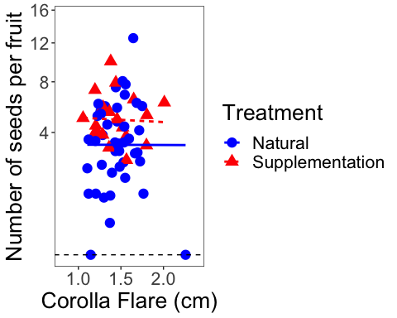

**ggplot**(fruit.sm, **aes**(x=Avg.TubeL,y=No.SeedsPerFruit, color=Treatment, shape=Treatment)) **+**  
 **geom_point**(size=4) **+**   
 **scale_y_continuous**(limits=**c**(0,15), trans="sqrt") **+**  
 **scale_colour_manual**(values=**c**("blue", "red")) **+**  
 **ylab**("Number of seeds per fruit") **+**  
 **xlab**("Tube Length (cm)") **+**  **geom_hline**(yintercept=0, linetype="dashed") **+**  
 **theme_bw**() **+**  
 **theme**(panel.grid.major = **element_blank**(), panel.grid.minor = **element_blank**(), text =**element_text**(size=20))

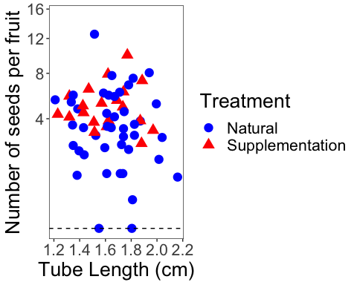

**ggplot**(fruit.sm, **aes**(x=Avg.LobeL,y=No.SeedsPerFruit, color=Treatment, shape=Treatment)) **+**  
 **geom_point**(size=4) **+**   
 **scale_y_sqrt**()**+**  
 **scale_colour_manual**(values=**c**("blue", "red")) **+**  
 **geom_smooth**(method='lm', fill=NA) **+**  
 **theme_bw**() **+**  
 **theme**(panel.grid.major = **element_blank**(), panel.grid.minor = **element_blank**(), text =**element_text**(size=20))

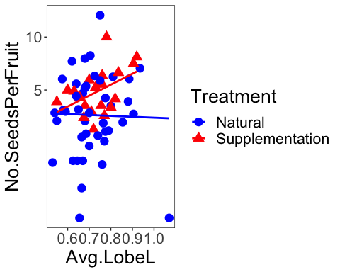

**Add tube length and lobe length to get corolla length**

fruit.sm**$**CorollaL <- fruit.sm**$**Avg.TubeL **+** fruit.sm**$**Avg.TubeL  
fit<-**lme**(**sqrt**(No.SeedsPerFruit)**~**Treatment**\***CorollaL, random=**~**1**|**Site**/**Habitat**/**Morph, data=fruit.sm, method="ML")    
**anova.lme**(fit)

##                    numDF denDF  F-value p-value  
## (Intercept)            1    49 45.45105  <.0001  
## Treatment              1    49  2.12481  0.1513  
## CorollaL               1    49  0.01197  0.9133  
## Treatment:CorollaL     1    49  0.06489  0.8000

**summary**(fit)

## Linear mixed-effects model fit by maximum likelihood  
##  Data: fruit.sm   
##        AIC     BIC    logLik  
##   129.5879 146.733 -56.79396  
##   
## Random effects:  
##  Formula: ~1 | Site  
##         (Intercept)  
## StdDev:   0.3994074  
##   
##  Formula: ~1 | Habitat %in% Site  
##          (Intercept)  
## StdDev: 3.413248e-05  
##   
##  Formula: ~1 | Morph %in% Habitat %in% Site  
##         (Intercept)  Residual  
## StdDev:  0.04586921 0.5635631  
##   
## Fixed effects: sqrt(No.SeedsPerFruit) ~ Treatment * CorollaL   
##                                        Value Std.Error DF    t-value  
## (Intercept)                        1.8304037 0.7624397 49  2.4007193  
## TreatmentSupplementation          -0.0847926 1.2907410 49 -0.0656930  
## CorollaL                          -0.0495814 0.2147534 49 -0.2308762  
## TreatmentSupplementation:CorollaL  0.1001903 0.3933092 49  0.2547367  
##                                   p-value  
## (Intercept)                        0.0202  
## TreatmentSupplementation           0.9479  
## CorollaL                           0.8184  
## TreatmentSupplementation:CorollaL  0.8000  
##  Correlation:   
##                                   (Intr) TrtmnS CorllL  
## TreatmentSupplementation          -0.516                
## CorollaL                          -0.941  0.546         
## TreatmentSupplementation:CorollaL  0.510 -0.992 -0.547  
##   
## Standardized Within-Group Residuals:  
##        Min         Q1        Med         Q3        Max   
## -3.5040031 -0.5372276 -0.0903510  0.6228894  2.7256253   
##   
## Number of Observations: 63  
## Number of Groups:   
##                         Site            Habitat %in% Site   
##                            3                            6   
## Morph %in% Habitat %in% Site   
##                           11

**Seeds per plant**

**qqnorm**(fruit.sm**$**Total.SeedsPerPlant)  
**qqline**(fruit.sm**$**Total.SeedsPerPlant)

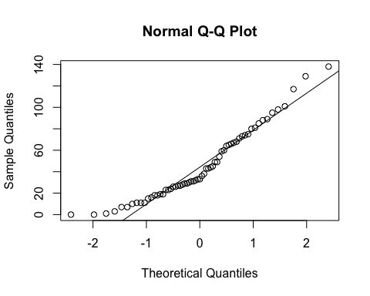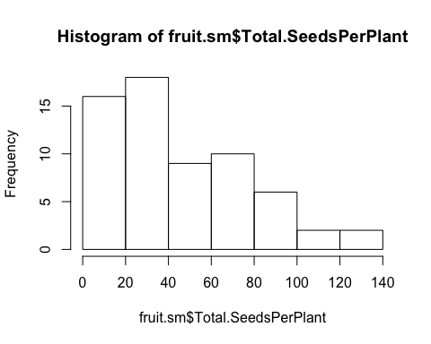

**hist**(fruit.sm**$**Total.SeedsPerPlant)

**qqnorm**(**sqrt**(fruit.sm**$**Total.SeedsPerPlant))  
**qqline**(**sqrt**(fruit.sm**$**Total.SeedsPerPlant))

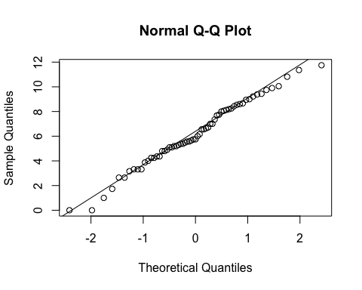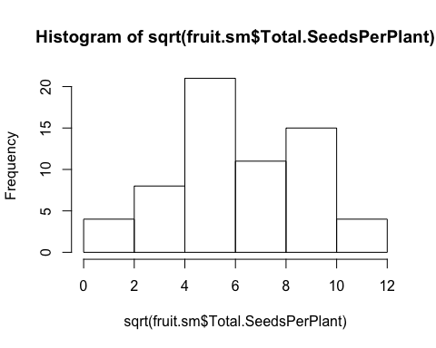

**hist**(**sqrt**(fruit.sm**$**Total.SeedsPerPlant))

fit<-**lme**(**sqrt**(Total.SeedsPerPlant)**~**Treatment**\***Avg.CorollaFlare, random=**~**1**|**Site**/**Habitat**/**Morph, data=fruit.sm, method="ML", na.action=na.omit)    
**anova.lme**(fit)

##                            numDF denDF  F-value p-value  
## (Intercept)                    1    49 34.38847  <.0001  
## Treatment                      1    49  0.50732  0.4797  
## Avg.CorollaFlare               1    49  1.57137  0.2160  
## Treatment:Avg.CorollaFlare     1    49  0.14191  0.7080

**summary**(fit)

## Linear mixed-effects model fit by maximum likelihood  
##  Data: fruit.sm   
##        AIC      BIC    logLik  
##   309.7805 326.9255 -146.8902  
##   
## Random effects:  
##  Formula: ~1 | Site  
##         (Intercept)  
## StdDev:    1.449129  
##   
##  Formula: ~1 | Habitat %in% Site  
##          (Intercept)  
## StdDev: 0.0001741057  
##   
##  Formula: ~1 | Morph %in% Habitat %in% Site  
##         (Intercept) Residual  
## StdDev:   0.2469176 2.365834  
##   
## Fixed effects: sqrt(Total.SeedsPerPlant) ~ Treatment * Avg.CorollaFlare   
##                                               Value Std.Error DF  
## (Intercept)                                8.566089  2.728460 49  
## TreatmentSupplementation                  -1.238176  4.506647 49  
## Avg.CorollaFlare                          -2.195952  1.796581 49  
## TreatmentSupplementation:Avg.CorollaFlare  1.140959  3.028699 49  
##                                              t-value p-value  
## (Intercept)                                3.1395330  0.0029  
## TreatmentSupplementation                  -0.2747445  0.7847  
## Avg.CorollaFlare                          -1.2222951  0.2274  
## TreatmentSupplementation:Avg.CorollaFlare  0.3767157  0.7080  
##  Correlation:   
##                                           (Intr) TrtmnS Avg.CF  
## TreatmentSupplementation                  -0.575                
## Avg.CorollaFlare                          -0.936  0.612         
## TreatmentSupplementation:Avg.CorollaFlare  0.565 -0.988 -0.611  
##   
## Standardized Within-Group Residuals:  
##        Min         Q1        Med         Q3        Max   
## -1.9773802 -0.7097765 -0.1428479  0.8041358  2.3328699   
##   
## Number of Observations: 63  
## Number of Groups:   
##                         Site            Habitat %in% Site   
##                            3                            6   
## Morph %in% Habitat %in% Site   
##                           11

fit<-**lme**(**sqrt**(Total.SeedsPerPlant)**~**Treatment**\***Avg.TubeL, random=**~**1**|**Site**/**Habitat**/**Morph, data=fruit.sm, method="ML", na.action=na.omit)    
**anova.lme**(fit)

##                     numDF denDF  F-value p-value  
## (Intercept)             1    49 46.97726  <.0001  
## Treatment               1    49  0.61462  0.4368  
## Avg.TubeL               1    49  0.11153  0.7398  
## Treatment:Avg.TubeL     1    49  0.00234  0.9616

**summary**(fit)

## Linear mixed-effects model fit by maximum likelihood  
##  Data: fruit.sm   
##        AIC      BIC    logLik  
##   311.2647 328.4098 -147.6324  
##   
## Random effects:  
##  Formula: ~1 | Site  
##         (Intercept)  
## StdDev:    1.211982  
##   
##  Formula: ~1 | Habitat %in% Site  
##          (Intercept)  
## StdDev: 0.0001179221  
##   
##  Formula: ~1 | Morph %in% Habitat %in% Site  
##          (Intercept) Residual  
## StdDev: 0.0002299894 2.421856  
##   
## Fixed effects: sqrt(Total.SeedsPerPlant) ~ Treatment * Avg.TubeL   
##                                        Value Std.Error DF    t-value  
## (Intercept)                         4.527678  3.165492 49  1.4303236  
## TreatmentSupplementation            0.829028  5.490710 49  0.1509875  
## Avg.TubeL                           0.559507  1.830152 49  0.3057162  
## TreatmentSupplementation:Avg.TubeL -0.162118  3.350201 49 -0.0483905  
##                                    p-value  
## (Intercept)                         0.1590  
## TreatmentSupplementation            0.8806  
## Avg.TubeL                           0.7611  
## TreatmentSupplementation:Avg.TubeL  0.9616  
##  Correlation:   
##                                    (Intr) TrtmnS Avg.TL  
## TreatmentSupplementation           -0.532                
## Avg.TubeL                          -0.965  0.550         
## TreatmentSupplementation:Avg.TubeL  0.525 -0.992 -0.549  
##   
## Standardized Within-Group Residuals:  
##        Min         Q1        Med         Q3        Max   
## -2.6492255 -0.6631592 -0.2230908  0.7759071  2.2094121   
##   
## Number of Observations: 63  
## Number of Groups:   
##                         Site            Habitat %in% Site   
##                            3                            6   
## Morph %in% Habitat %in% Site   
##                           11

**FLOWER SIZE by habitat and morph**

**Notes from Niki’s last analysis:**

*no difference in flower size by scent morph or habitat => sweet and skunky have the same size flowers*

flowers are cumberland pass are smaller than niwot ridge & penn mountain.

*This parallels differences in seed set, but when we test for a direct relationship via regression (see below), there is no difference*

*Perhaps it has more to do with a weather effect, since selection doesn’t vary among sites??? [stilll need to verify this last statement]*

**qqnorm**(flwr.nat**$**Avg.CorollaFlare)  
**qqline**(flwr.nat**$**Avg.CorollaFlare)

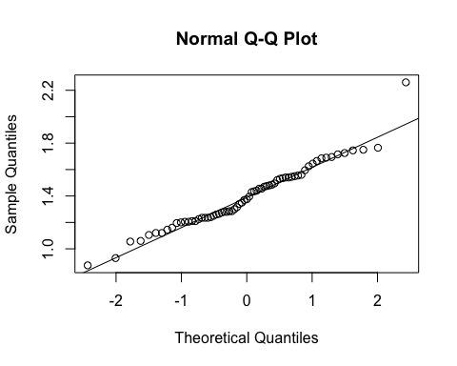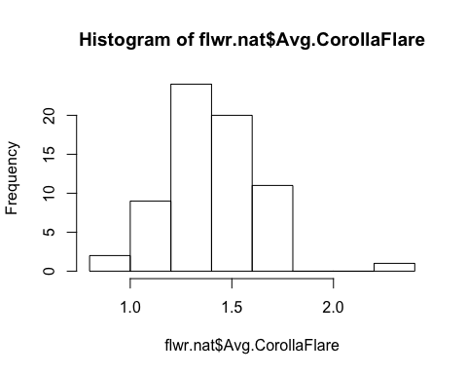

**hist**(flwr.nat**$**Avg.CorollaFlare)

fit<-**lm**(Avg.CorollaFlare**~**Site, data=flwr.nat, na.action=na.omit)    
**anova**(fit)

## Analysis of Variance Table  
##   
## Response: Avg.CorollaFlare  
##           Df  Sum Sq Mean Sq F value    Pr(>F)      
## Site       2 0.88461  0.4423  10.286 0.0001339 ***  
## Residuals 64 2.75216  0.0430                        
## ---  
## Signif. codes:  0 '***' 0.001 '**' 0.01 '*' 0.05 '.' 0.1 ' ' 1

**TukeyHSD**(**aov**(Avg.CorollaFlare**~**Site, data=flwr.nat, na.action=na.omit))

##   Tukey multiple comparisons of means  
##     95% family-wise confidence level  
##   
## Fit: aov(formula = Avg.CorollaFlare ~ Site, data = flwr.nat, na.action = na.omit)  
##   
## $Site  
##                                     diff         lwr       upr     p adj  
## Niwot Ridge-Cumberland Pass   0.22016082  0.05650121 0.3838204 0.0055154  
## Penn Mountain-Cumberland Pass 0.26943860  0.12355236 0.4153248 0.0001098  
## Penn Mountain-Niwot Ridge     0.04927778 -0.09906877 0.1976243 0.7061896

**ggplot**(flwr.nat, **aes**(x=Site,y=Avg.CorollaFlare)) **+**  
 **geom_boxplot**() **+**   
 **theme_bw**() **+**  
 **theme**(panel.grid.major = **element_blank**(), panel.grid.minor = **element_blank**(), text =**element_text**(size=20))

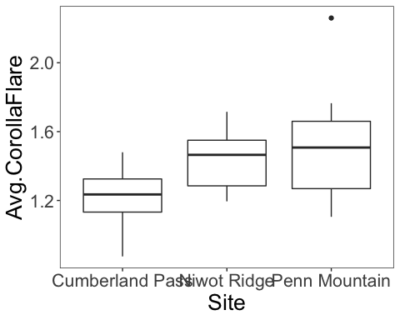

fit<-**lme**(Avg.CorollaFlare**~**Site, random=**~**1**|**Morph, data=flwr.nat, method="ML", na.action=na.omit)    
**anova.lme**(fit)

##             numDF denDF   F-value p-value  
## (Intercept)     1    63 3043.6925  <.0001  
## Site            2    63   10.2855   1e-04

fit<-**lme**(Avg.CorollaFlare**~**Habitat**\***Morph, random=**~**1**|**Site, data=flwr.nat, method="ML", na.action=na.omit)    
**anova.lme**(fit)

##               numDF denDF  F-value p-value  
## (Intercept)       1    61 326.7009  <.0001  
## Habitat           1    61   1.7298  0.1934  
## Morph             1    61   0.4290  0.5150  
## Habitat:Morph     1    61   0.1262  0.7237

fit<-**lm**(Avg.CorollaFlare**~**Site**\***Morph, data=flwr.nat, na.action=na.omit)    
**Anova**(fit,type="III")

## Anova Table (Type III tests)  
##   
## Response: Avg.CorollaFlare  
##              Sum Sq Df  F value Pr(>F)      
## (Intercept) 16.3840  1 380.9275 <2e-16 ***  
## Site         0.1612  2   1.8736 0.1623      
## Morph        0.0814  1   1.8932 0.1739      
## Site:Morph   0.1279  2   1.4865 0.2342      
## Residuals    2.6237 61                      
## ---  
## Signif. codes:  0 '***' 0.001 '**' 0.01 '*' 0.05 '.' 0.1 ' ' 1

fit<-**lm**(Avg.CorollaFlare**~**Site**\***Morph**\***Habitat, data=flwr.nat, na.action=na.omit)    
**anova**(fit) *# unbalanced, so cannot run type 3.*

## Analysis of Variance Table  
##   
## Response: Avg.CorollaFlare  
##               Df  Sum Sq Mean Sq F value    Pr(>F)      
## Site           2 0.88461 0.44230 10.1313 0.0001719 ***  
## Morph          1 0.00063 0.00063  0.0145 0.9046879      
## Habitat        1 0.10749 0.10749  2.4623 0.1221465      
## Site:Morph     2 0.08515 0.04258  0.9752 0.3833099      
## Site:Habitat   2 0.06354 0.03177  0.7277 0.4874450      
## Morph:Habitat  1 0.00688 0.00688  0.1577 0.6927604      
## Residuals     57 2.48846 0.04366                        
## ---  
## Signif. codes:  0 '***' 0.001 '**' 0.01 '*' 0.05 '.' 0.1 ' ' 1

**qqnorm**(flwr.nat**$**Avg.TubeL)  
**qqline**(flwr.nat**$**Avg.TubeL)

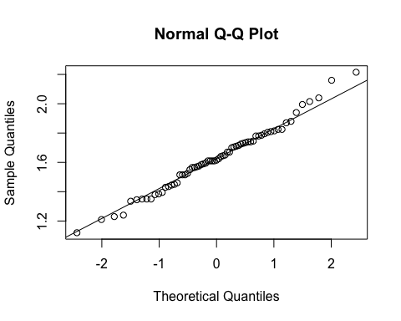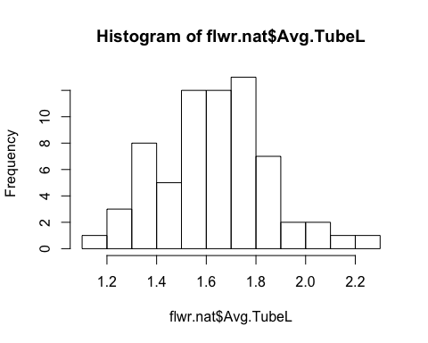

**hist**(flwr.nat**$**Avg.TubeL)

fit<-**lm**(Avg.TubeL**~**Site, data=flwr.nat, na.action=na.omit)    
**anova**(fit)

## Analysis of Variance Table  
##   
## Response: Avg.TubeL  
##           Df Sum Sq  Mean Sq F value Pr(>F)  
## Site       2 0.0433 0.021657  0.4341 0.6497  
## Residuals 64 3.1927 0.049887

fit<-**lme**(Avg.TubeL**~**Habitat**\***Morph, random=**~**1**|**Site, data=flwr.nat, method="ML", na.action=na.omit)    
**anova.lme**(fit)

##               numDF denDF  F-value p-value  
## (Intercept)       1    61 3620.624  <.0001  
## Habitat           1    61    1.668  0.2014  
## Morph             1    61    0.663  0.4186  
## Habitat:Morph     1    61    0.608  0.4384

fit<-**lm**(Avg.TubeL**~**Site**\***Morph, data=flwr.nat, na.action=na.omit)    
**Anova**(fit,type="III")

## Anova Table (Type III tests)  
##   
## Response: Avg.TubeL  
##              Sum Sq Df  F value  Pr(>F)      
## (Intercept) 28.8830  1 609.4369 < 2e-16 ***  
## Site         0.1386  2   1.4621 0.23977      
## Morph        0.0222  1   0.4675 0.49675      
## Site:Morph   0.2398  2   2.5294 0.08804 .    
## Residuals    2.8910 61                       
## ---  
## Signif. codes:  0 '***' 0.001 '**' 0.01 '*' 0.05 '.' 0.1 ' ' 1

fit<-**lm**(Avg.TubeL**~**Site**\***Morph**\***Habitat, data=flwr.nat, na.action=na.omit)    
**anova**(fit) *# unbalanced, so cannot run type 3.*

## Analysis of Variance Table  
##   
## Response: Avg.TubeL  
##               Df  Sum Sq  Mean Sq F value  Pr(>F)    
## Site           2 0.04331 0.021657  0.4992 0.60967    
## Morph          1 0.06202 0.062016  1.4294 0.23682    
## Habitat        1 0.05313 0.053134  1.2246 0.27310    
## Site:Morph     2 0.28845 0.144226  3.3241 0.04310 *  
## Site:Habitat   2 0.24178 0.120890  2.7863 0.07006 .  
## Morph:Habitat  1 0.07427 0.074267  1.7117 0.19602    
## Residuals     57 2.47309 0.043387                    
## ---  
## Signif. codes:  0 '***' 0.001 '**' 0.01 '*' 0.05 '.' 0.1 ' ' 1

measures <- **c**("Avg.CorollaFlare", "Avg.TubeL", "Avg.LobeL", "Avg.LobW")  
flwr.size<-**as.matrix**(**subset**(flwr.nat, select=measures))  
pc<-**prcomp**(flwr.size,center=TRUE)  
**print**(pc)

## Standard deviations (1, .., p=4):  
## [1] 0.26375496 0.20976301 0.08825506 0.06486573  
##   
## Rotation (n x k) = (4 x 4):  
##                        PC1         PC2         PC3         PC4  
## Avg.CorollaFlare 0.8192268 -0.40655518 -0.35567419 -0.19255163  
## Avg.TubeL        0.4468626  0.89354307 -0.01435364  0.04109264  
## Avg.LobeL        0.2435860 -0.08932854  0.87933763 -0.39931394  
## Avg.LobW         0.2642860 -0.16826787  0.31631500  0.89542372

**plot**(pc, type="l")

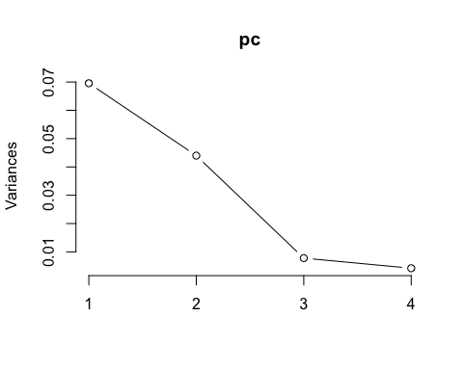

**summary**(pc)

## Importance of components:  
##                           PC1    PC2     PC3     PC4  
## Standard deviation     0.2638 0.2098 0.08826 0.06487  
## Proportion of Variance 0.5540 0.3504 0.06203 0.03351  
## Cumulative Proportion  0.5540 0.9045 0.96649 1.00000

pc.extracted <- **as.data.frame**(**predict**(pc, newdata=flwr.nat))  
flwr.nat**$**PC1.all <- pc.extracted**$**PC1   
**qqnorm**(flwr.nat**$**PC1.all)  
**qqline**(flwr.nat**$**PC1.all)

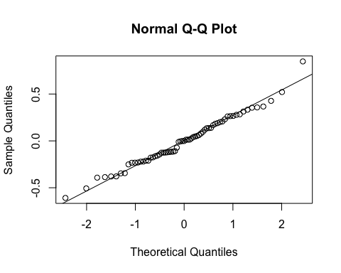

fit<-**lm**(PC1.all**~**Site, data=flwr.nat, na.action=na.omit)    
**anova**(fit)

## Analysis of Variance Table  
##   
## Response: PC1.all  
##           Df Sum Sq Mean Sq F value   Pr(>F)     
## Site       2 0.6925 0.34625  5.6837 0.005344 **  
## Residuals 64 3.8989 0.06092                      
## ---  
## Signif. codes:  0 '***' 0.001 '**' 0.01 '*' 0.05 '.' 0.1 ' ' 1

**ggplot**(flwr.nat, **aes**(x=Site,y=PC1.all)) **+**  
 **geom_boxplot**() **+**   
 **theme_bw**() **+**  
 **theme**(panel.grid.major = **element_blank**(), panel.grid.minor = **element_blank**(), text =**element_text**(size=20))

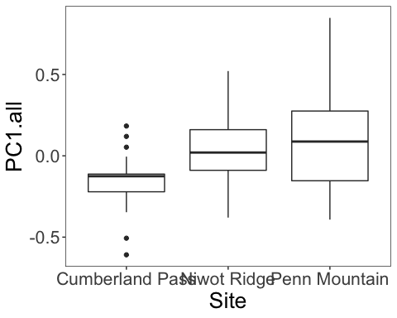

fit<-**lme**(PC1.all**~**Habitat**\***Morph, random=**~**1**|**Site, data=flwr.nat, method="ML", na.action=na.omit)    
**anova.lme**(fit)

##               numDF denDF   F-value p-value  
## (Intercept)       1    61 0.0324805  0.8576  
## Habitat           1    61 0.1139159  0.7369  
## Morph             1    61 0.2167850  0.6432  
## Habitat:Morph     1    61 0.4024498  0.5282

fit<-**lm**(PC1.all**~**Site**\***Morph, data=flwr.nat, na.action=na.omit)    
**Anova**(fit,type="III")

## Anova Table (Type III tests)  
##   
## Response: PC1.all  
##             Sum Sq Df F value Pr(>F)  
## (Intercept) 0.0884  1  1.4188 0.2382  
## Site        0.1338  2  1.0734 0.3482  
## Morph       0.0915  1  1.4683 0.2303  
## Site:Morph  0.0863  2  0.6924 0.5043  
## Residuals   3.8019 61